OctaMetatron
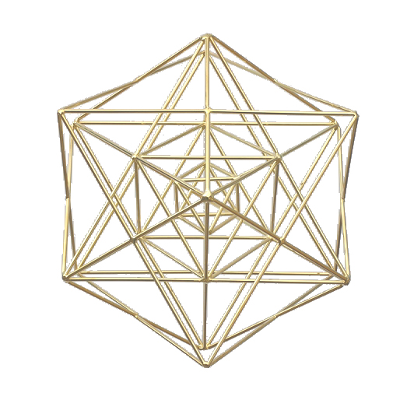
A powerful form for manifestation and personal integration
• Works like a muse; activates stream of conscious writing, talking, and discovery.
• Opens doorways into the very nature of existence and awakens the understanding of "all that is, as it is".
• Supports deep release and letting go so forgiveness transforms into gratefulness'.
• A wonderful form to unblock and transform karmic ties and liberate one from lost will relationships.
The OctaMetatron contains three octahedrons - one inside the other, spaced at a Phi Ratio. Each one is twice the size as the one nested within it. This creates three distinct energy flows in one form to promote spiritual integration, deep emotional healing, mental clarity, and physical manifestation. The number three links people into the infinite progression of dimensional reality.
The OctaMetatron represents an ancient power as it works with emotions and helps to clarify them and transform them safely with a loving innocence. Stars, diamonds, and squares create a fountain of abundant beauty with a passion for freedom. A profound tool for accessing and grounding the powers of true esteem an autonomy. Working with Metatron, the Archangel for outer expression, this form assists us to transform inner, perhaps unseen patterns, which block our creative manifesting abilities.
The OctaMetatron is 3 forms in one. It can be hung using any one of 3 distinct axis and each axis radiates a unique energy to either release, manifest, or integrate. These transforming energies can dissolve blocks to personal expression and growth so one’s reality aligns to their intent.

